SCHOOL OF TECHNOLOGY | 

DATABASE MANAGEMENT SYSTEMS
PROJECT-BASED LEARNING (PBL) REPORT
INDIVIDUAL DATABASE DESIGN REPORT
PROJECT TITLE
Design and Implementation of a Database Management System for Faculty Workload and Timetable Management System
Program | B-Tech
Section | AIML Rhinos
Faculty | Sahithi Ma’am
Date of Submission | 5 October 2026
Academic Year | 2026-27
Submitted by
Roll Number | Student Name | Mobile | Email ID
25WU0102336 | Rushmitha Reddy | 7569844479 | rushmitha.reddy_2029@woxsen.edu.in

ACKNOWLEDGEMENT
I would like to thank Woxsen University, School of Technology, for the opportunity to complete this individual DBMS Project-Based Learning report.
I am grateful to my course faculty for guidance during the requirements analysis and database design. The work helped me apply ER modelling, functional dependencies, normalization, integrity constraints and SQL to a timetable-planning problem.
Working through the entity relationships, constraints and sample queries improved my understanding of how database design supports academic planning.

UNDERTAKING
I, Rushmitha Reddy (Roll Number 25WU0102336), declare that this report entitled "Design and Implementation of a Database Management System for Faculty Workload and Timetable Management System" is my individual work prepared for the Database Management Systems Project-Based Learning activity.
The report documents a proposed database design, representative SQL and design-level test cases. It does not claim a deployed database, a completed application or executed test results.
I have cited the sources used in this report. I understand that I am responsible for checking the design, completing details marked Not supplied and confirming that this report reflects the work accepted by the course faculty before submission.
 |  |  |  | Signature
Date | : | 5 October 2026 | Name: | Rushmitha Reddy
Place | : | Woxsen University | Roll Number: | 25WU0102336
 |  |  | Program: | B-Tech

TABLE OF CONTENTS
Contents | Page No.
Abstract | 8
LIST OF TABLES | 5
LIST OF FIGURES | 6
LIST OF ACRONYMS | 7
1. PROBLEM STATEMENT, SOLUTION STRATEGY AND ER DIAGRAM | 9
1.1 Problem Statement | 9
1.2 Objectives | 9
1.3 Scope and Assumptions | 9
1.4 Proposed Solution Strategy | 9
1.5 Functional Requirements | 10
1.6 Entity-Relationship Diagram (ERD) | 10
1.7 Entity and Relationship Summary | 11
2. LOGICAL DATABASE DESIGN | 13
2.1 Relational Schema | 13
2.2 Keys and Integrity Constraints | 14
2.3 Functional Dependencies | 15
2.4 Normalization up to Third Normal Form (3NF) | 16
2.5 Data Dictionary | 17
2.6 DDL and Sample Data | 21
3. APPLICATION DESIGN USING LOGICAL DATABASE DESIGN | 23
3.1 Application Overview | 23
3.2 Development Environment and Database Connectivity | 23
3.3 Application Modules and Database Mapping | 23
3.4 CRUD Operations | 24
3.5 Business Rules, Validation and Error Handling | 24
3.6 Reports and Database Operations | 25
3.7 Application Screens | 25
3.8 Testing and Results | 25
4. CONCLUSION | 27
4.1 Limitations and Future Enhancements | 27
5. REFERENCES | 28
6. APPENDICES | 29

LIST OF TABLES
Table No. | Table Title | Page No.
Table 1 | Scope and Assumptions | 9
Table 2 | Proposed Solution Strategy | 10
Table 3 | Functional Requirements | 10
Table 4 | Entity and Relationship Summary | 11
Table 5 | Relational Schema | 13
Table 6 | Keys and Integrity Constraints | 14
Table 7 | Normalization Status up to 3NF | 16
Table 8 | Data Dictionary | 17
Table 9 | Database Implementation Environment | 21
Table 10 | Application Development Environment | 23
Table 11 | Application Module-to-Database Mapping | 23
Table 12 | CRUD Operations | 24
Table 13 | Business Rules, Validation and Error Handling | 24
Table 14 | Reports and Database Operations | 25
Table 15 | Test Cases | 25

LIST OF FIGURES
Figure No. | Figure Title | Page No.
Figure 1 | Entity-Relationship Diagram of the Proposed System | 11

LIST OF ACRONYMS
Acronym | Expansion
3NF | Third Normal Form
DBMS | Database Management System
ER | Entity-Relationship
ERD | Entity-Relationship Diagram
FD | Functional Dependency
FK | Foreign Key
PK | Primary Key
SQL | Structured Query Language
UK | Unique Key

ABSTRACT
Department timetable planning brings together course offerings, student sections, faculty availability, workload limits, rooms and weekly time slots. When these details are kept in separate spreadsheets, a change can be missed and the same room, faculty member or section can be scheduled twice. This report presents the design of a relational database for a Faculty Workload and Timetable Management System. The requirements are represented with an entity-relationship model and mapped to a logical schema of fourteen relations. Functional dependencies are identified and the design is reviewed through Third Normal Form. The proposed PostgreSQL schema uses primary and foreign keys, unique and check constraints, effective-date rules, and trigger-based checks for workload limits, room capacity and timetable clashes. Synthetic records and SQL examples are provided for workload summaries, section timetables, available room slots, room use, clashes and substitutions. A small Python client is described as a future interface for coordinators and faculty, but no application is built or claimed in this report. The main outcome is a consistent database design that can be implemented and tested in a later project stage.

KEYWORDS
Keywords: faculty workload, timetable scheduling, PostgreSQL, 3NF, ER modelling, clash detection

CHAPTER 1

PROBLEM STATEMENT, SOLUTION STRATEGY AND ER DIAGRAM

1.1 Problem Statement
Departments often prepare faculty allocations and weekly timetables in separate spreadsheets. Course details, section sizes, faculty loads, room capacities and time slots are entered in more than one place. A change to one sheet may not reach the others, so a faculty member, room or section can be booked twice. Spreadsheet formulas also do not reliably enforce workload limits or effective dates.

1.2 Objectives
- Design an ER model for the department, programme, course, term, section, faculty, workload norm, room, time slot, assignment, timetable and substitution records.
- Map the model to a relational schema and document the functional dependencies and normalization through 3NF.
- Specify PostgreSQL DDL and integrity checks for workload limits, room capacity, valid dates and timetable conflicts.
- Prepare synthetic sample data and SQL examples for six reports, then document a future database-connected client and its acceptance tests.

1.3 Scope and Assumptions
Table 1 defines the scope of this report and the assumptions used to keep the database design manageable.
Table 1. Scope and Assumptions
Item | Description
In Scope | Requirements analysis, ER model, 3NF relational schema, PostgreSQL DDL, integrity rules, synthetic sample data, SQL queries/views and a proposed client workflow.
Out of Scope / Exclusions | No executable Java/Python application, live deployment, login system, student-information/HR integration, mobile interface or automatic optimizer.
Assumptions | One university instance; one primary faculty member per course-section; weekly recurring slots within a term; end dates are exclusive; sample records are fictional.

1.4 Proposed Solution Strategy
The proposed design separates reference data from term-specific assignments and schedule events. A department coordinator maintains the master records, assigns courses to sections and faculty, and schedules each weekly meeting. Database constraints protect single-row rules; trigger functions check rules that depend on related rows. A planned Python client would submit changes as parameterized transactions and display the resulting reports. Table 2 summarizes the user roles, workflow, business rules and expected outputs.
Table 2. Proposed Solution Strategy
Solution Element | Project-Specific Description
Primary Users / Roles | Department coordinator plans allocations; faculty view their load and timetable; academic administrator maintains terms and reference data.
Major Application Modules | Reference data; faculty and norms; course allocation; timetable planning; substitutions; audit and reporting.
Proposed Workflow | Set up a term and sections, maintain courses/faculty/rooms, allocate courses, enter weekly slots, validate, record substitutions and run reports.
Important Business Rules | Enforce faculty workload limits, no overlap for faculty/room/section, room capacity at least section size, and valid effective dates.
Expected Reports / Outputs | Faculty workload, section timetable, free room slots, room utilization, clash pairs and approved substitutions.

1.5 Functional Requirements
Table 3 lists the functions needed to maintain allocations, prepare the timetable and produce the required reports.
Table 3. Functional Requirements
Req. ID | Functional Requirement | Remarks / Priority
FR-01 | Maintain departments, programme, courses, terms, sections, faculty, norms, rooms and time slots. | High; reference data.
FR-02 | Assign a course to a section and one primary faculty member; calculate term workload. | High; reject workload over the effective norm.
FR-03 | Create or revise recurring timetable entries with room, slot and effective dates. | High; reject faculty, room, section and capacity conflicts.
FR-04 | Record a date-specific faculty substitution and retain a change-history row. | Medium; validate date, faculty availability and approval status.
FR-05 | Generate workload, timetable, free-slot, utilization, clash and substitution reports. | High; filter by term, section, room or faculty.

1.6 Entity-Relationship Diagram (ERD)
Figure 1 shows the principal entities, key attributes and one-to-many relationships. The relationship list is shown beside the entity boxes for readability; Table 4 summarizes the entities and cardinalities.
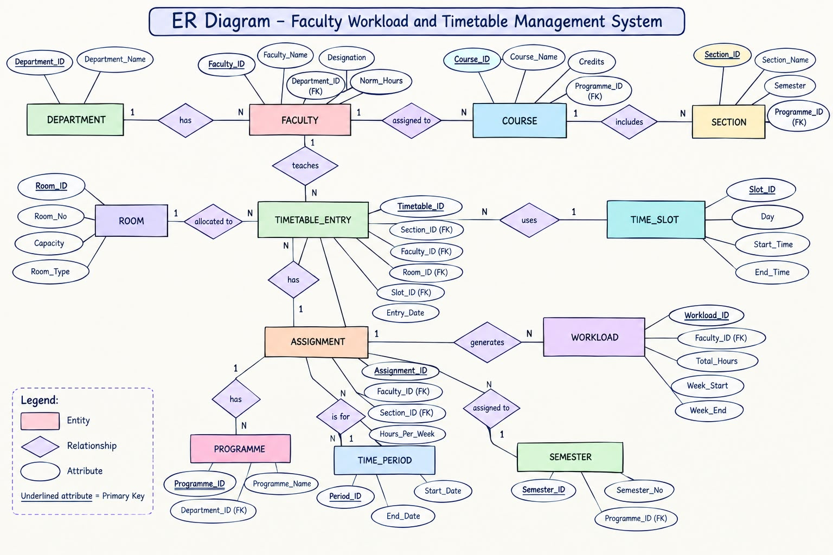Figure 1. Entity-Relationship Diagram of the Proposed System

1.7 Entity and Relationship Summary
Table 4. Entity and Relationship Summary
Entity / Relationship | Major Attributes / Cardinality | Purpose / Rule
Department | department_id, department_code, department_name | 1:M to programmes, courses and faculty; department codes are unique.
Programme | programme_id, department_id, programme_code, name, level | Belongs to one department; 1:M to sections.
Course | course_id, department_id, course_code, title, credits, weekly_hours | Belongs to one department; weekly hours feed workload calculations.
Academic Term | term_id, academic_year, term_name, starts_on, ends_on | 1:M to sections; the end date is exclusive.
Section | section_id, programme_id, term_id, section_code, cohort_size | Belongs to one programme and term; 1:M to course assignments.
Faculty | faculty_id, department_id, employee_no, name, email, designation | Belongs to one department; 1:M to assignments and norm mappings.
WorkloadNorm | norm_id, designation, maximum hours, valid dates | Effective-dated limit; 1:M to faculty norm mappings.
FacultyNorm | faculty_norm_id, faculty_id, norm_id, effective dates | Associative entity; one applicable norm per faculty period.
Room | room_id, room_code, building, capacity, room_type | 1:M to timetable entries; capacity must fit the assigned section.
TimeSlot | slot_id, slot_code, weekday, start_time, end_time | 1:M to timetable entries; represents a recurring weekly interval.
CourseAssignment | assignment_id, course_id, section_id, faculty_id, status | Links one course, section and primary faculty; unique course/section.
TimetableEntry | entry_id, assignment_id, room_id, slot_id, effective dates | Recurring meeting; trigger prevents conflicts for all three resources.
Substitution | substitution_id, entry_id, substitute_faculty_id, date, reason | Date-specific change; one event per timetable entry and date.
ChangeLog | change_id, entity_name, record_key, action, actor, time, summary | Generic audit event; record_key refers to a row in the named relation.

CHAPTER 2

LOGICAL DATABASE DESIGN
The ER model maps to fourteen relations. Parent records are separated from assignments and schedule events so that a course, faculty member or room is stored once. Dates use an inclusive start and exclusive end. The schema targets PostgreSQL 16 and is presented as a design specification, not as a deployed database.

2.1 Relational Schema
Table 5 lists the relations with their primary keys (PK), foreign keys (FK) and alternate unique keys (UQ). Standard relational design principles reduce repeated facts and update anomalies [1].
Table 5. Relational Schema
S.No. | Table Name | Purpose / Key Structure
1 | department | department_id PK; department_code UQ; department_name UQ. Stores each academic department.
2 | programme | programme_id PK; department_id FK; (department_id, programme_code) UQ. Stores programme details.
3 | course | course_id PK; department_id FK; (department_id, course_code) UQ. Stores credits and weekly teaching hours.
4 | academic_term | term_id PK; (academic_year, term_name) UQ. Stores half-open term dates.
5 | section | section_id PK; programme_id FK; term_id FK; (programme_id, term_id, section_code) UQ.
6 | faculty | faculty_id PK; department_id FK; employee_no UQ; email UQ. Stores faculty identity and status.
7 | workload_norm | norm_id PK; (designation, valid_from) UQ; effective-dated weekly workload limit.
8 | faculty_norm | faculty_norm_id PK; faculty_id FK; norm_id FK; effective-dated norm assignment.
9 | room | room_id PK; room_code UQ. Stores room type, building and capacity.
10 | time_slot | slot_id PK; slot_code UQ. Stores weekday and start/end times.
11 | course_assignment | assignment_id PK; course_id, section_id, faculty_id FKs; (course_id, section_id) UQ.
12 | timetable_entry | entry_id PK; assignment_id, room_id, slot_id FKs; effective date window and status.
13 | substitution | substitution_id PK; entry_id, substitute_faculty_id FKs; one row per entry and date.
14 | change_log | change_id PK; generic entity name, record key, action, actor, time and summary.

2.2 Keys and Integrity Constraints
Table 6. Keys and Integrity Constraints
Table Name | Key / Constraint | Attribute(s) | Business Rule Enforced
department | PK, UNIQUE, NOT NULL | department_id; department_code; department_name | Prevents duplicate departments and missing identifiers.
department | FK, UNIQUE, CHECK | department_id; department-specific codes; positive duration, credits and hours | Keeps each programme/course under one department; rejects invalid values.
department | CHECK, UNIQUE, FK | starts_on < ends_on; unique year/term; unique programme/term/section | Defines valid term windows and one section code per programme term.
department | UNIQUE, NOT NULL, DEFAULT | employee_no; email; active DEFAULT TRUE | Identifies a faculty member and gives a controlled active status.
department | CHECK, EXCLUDE | valid_to > valid_from; non-overlapping date ranges by designation/faculty | Prevents invalid or overlapping effective norm periods.
course_assignment | FK, UNIQUE, CHECK, DEFAULT, trigger | one course per section; ACTIVE/INACTIVE; active faculty weekly hours <= applicable norm | Avoids duplicate allocations and rejects workload overflow.
course_assignment | CHECK, UNIQUE | weekday 1-7; start_time < end_time; unique slot code | Rejects invalid weekly slot definitions.
course_assignment | FK, CHECK, trigger | effective_to > effective_from; dates within term; room capacity >= cohort | Rejects invalid dates and rooms that are too small.
course_assignment | BEFORE INSERT/UPDATE trigger | compare date, weekday and time overlap for faculty, room and section | Rejects any active resource clash; resource rows are locked during the check.
course_assignment | UNIQUE, CHECK, trigger | unique entry/date; APPROVED/PENDING/CANCELLED; date inside entry window | Rejects invalid dates, self-substitution and substitute-faculty clashes.
course_assignment | PK, NOT NULL, DEFAULT | changed_at DEFAULT CURRENT_TIMESTAMP; action check | Stores a timestamped audit event; record_key is generic because events cover several tables.
Table 6 summarizes the key and integrity rules. Single-row rules are expressed as NOT NULL, UNIQUE, CHECK and DEFAULT constraints. Workload, capacity, date-window and clash rules depend on related rows, so the design uses triggers and transactions rather than cross-table CHECK expressions [2]. PostgreSQL date ranges use [start, end) boundaries to make adjacent periods non-overlapping [3]. Concurrent schedule writes should use a SERIALIZABLE transaction and retry serialization failures [4].

2.3 Functional Dependencies
The following functional dependencies identify the candidate keys and the attributes determined by each key. Alternate natural keys are included where they are enforced by UNIQUE constraints [1]. Table 7 summarizes the normal-form status of each relation.
- department_id - department_code, department_name; department_code - department_id, department_name.
- programme_id - department_id, programme_code, programme_name, level, duration_years; (department_id, programme_code) - the programme description.
- course_id - department_id, course_code, title, credits, weekly_hours, course_type; (department_id, course_code) - the course description.
- term_id - academic_year, term_name, starts_on, ends_on; (academic_year, term_name) - the term description.
- section_id - programme_id, term_id, section_code, cohort_size; (programme_id, term_id, section_code) - the section description.
- faculty_id - department_id, employee_no, full_name, email, designation, active; employee_no and email each identify one faculty row.
- norm_id - designation, max_weekly_hours, valid_from, valid_to; (designation, valid_from) - the norm row.
- faculty_norm_id - faculty_id, norm_id, effective_from, effective_to; (faculty_id, effective_from) - the norm assignment.
- room_id - room_code, building, capacity, room_type; room_code - the room description.
- slot_id - slot_code, day_of_week, start_time, end_time; slot_code - the weekly time slot.
- assignment_id - course_id, section_id, faculty_id, status, assigned_at; (course_id, section_id) - the primary assignment.
- entry_id - assignment_id, room_id, slot_id, effective_from, effective_to, status.
- substitution_id - entry_id, substitute_faculty_id, substitution_date, reason, status, created_by, created_at; (entry_id, substitution_date) - one substitution event.
- change_id - entity_name, record_key, action, changed_by, changed_at, change_summary.

2.4 Normalization
Table 7. Normalization Status up to Third Normal Form (3NF)
Relation Name | 1NF | 2NF | 3NF | BCNF | Remarks / Decomposition
Master relations: department, programme, course, faculty, room | Yes | Yes | Yes | Yes | Each row stores one fact; descriptive attributes depend on a candidate key.
academic_term, section, workload_norm | Yes | Yes | Yes | Yes | Date and programme facts are stored in their own relations; no partial or transitive dependency remains.
faculty_norm, course_assignment | Yes | Yes | Yes | Yes | Association facts are separate; surrogate PKs and natural UNIQUE keys identify rows.
time_slot, timetable_entry | Yes | Yes | Yes | Yes | Schedule rows reference resources instead of repeating room, course or faculty descriptions.
substitution, change_log | Yes | Yes | Yes | Yes | Each event is one row; audit summary is one text value, not a nested operational record.

2.5 Data Dictionary
Table 8 lists the attributes, PostgreSQL types, keys and rules for all fourteen relations.
Table 8. Data Dictionary
Table | Attribute | Data Type | Key / Constraint | Description
department | department_id | bigint | PK, identity | Department identifier.
department | department_code | varchar(10) | NOT NULL, UNIQUE | Short department code.
department | department_name | varchar(100) | NOT NULL, UNIQUE | Department name.
programme | programme_id | bigint | PK, identity | Programme identifier.
programme | department_id | bigint | FK -> department | Owning department.
programme | programme_code | varchar(15) | NOT NULL; unique per department | Programme code.
programme | programme_name | varchar(100) | NOT NULL | Programme name.
programme | level | varchar(20) | NOT NULL | Programme level, for example undergraduate.
programme | duration_years | smallint | CHECK 1-8 | Nominal programme duration.
course | course_id | bigint | PK, identity | Course identifier.
course | department_id | bigint | FK -> department | Owning department.
course | course_code | varchar(15) | NOT NULL; unique per department | Course code.
course | title | varchar(120) | NOT NULL | Course title.
course | credits | numeric(3,1) | CHECK > 0 | Credit value.
course | weekly_hours | numeric(4,1) | CHECK > 0 | Weekly teaching hours used for workload totals.
course | course_type | varchar(20) | CHECK Lecture/Lab/Mixed | Course delivery type.
academic_term | term_id | bigint | PK, identity | Academic term identifier.
academic_term | academic_year | varchar(9) | NOT NULL | Academic year label.
academic_term | term_name | varchar(20) | NOT NULL | Term label, unique within the academic year.
academic_term | starts_on | date | NOT NULL | Inclusive first date of the term.
academic_term | ends_on | date | CHECK > starts_on | Exclusive last date of the term.
section | section_id | bigint | PK, identity | Section identifier.
section | programme_id | bigint | FK -> programme | Programme that owns the section.
section | term_id | bigint | FK -> academic_term | Term in which the section runs.
section | section_code | varchar(10) | NOT NULL; unique in programme and term | Section label.
section | cohort_size | integer | CHECK > 0 | Expected student count used for room-capacity checks.
faculty | faculty_id | bigint | PK, identity | Faculty identifier.
faculty | department_id | bigint | FK -> department | Faculty department.
faculty | employee_no | varchar(15) | NOT NULL, UNIQUE | Institutional employee number.
faculty | full_name | varchar(100) | NOT NULL | Faculty name.
faculty | email | varchar(160) | NOT NULL, UNIQUE | Faculty email address.
faculty | designation | varchar(40) | NOT NULL | Designation used to select a workload norm.
faculty | active | boolean | NOT NULL DEFAULT TRUE | Whether new assignments may be created.
workload_norm | norm_id | bigint | PK, identity | Workload norm identifier.
workload_norm | designation | varchar(40) | NOT NULL; effective-date exclusion | Designation covered by the norm.
workload_norm | max_weekly_hours | numeric(4,1) | CHECK > 0 | Maximum assigned weekly teaching hours.
workload_norm | valid_from | date | NOT NULL | Inclusive first date of the norm.
workload_norm | valid_to | date | CHECK > valid_from | Exclusive end date of the norm.
faculty_norm | faculty_norm_id | bigint | PK, identity | Faculty-to-norm assignment identifier.
faculty_norm | faculty_id | bigint | FK -> faculty | Faculty covered by the norm.
faculty_norm | norm_id | bigint | FK -> workload_norm | Applicable norm.
faculty_norm | effective_from | date | NOT NULL | Inclusive first date of the mapping.
faculty_norm | effective_to | date | CHECK > effective_from; no faculty overlap | Exclusive end date of the mapping.
room | room_id | bigint | PK, identity | Room identifier.
room | room_code | varchar(20) | NOT NULL, UNIQUE | Room code.
room | building | varchar(60) | NOT NULL | Building or location name.
room | capacity | integer | CHECK > 0 | Maximum room occupancy.
room | room_type | varchar(20) | CHECK Classroom/Laboratory/Seminar | Room type.
time_slot | slot_id | bigint | PK, identity | Time-slot identifier.
time_slot | slot_code | varchar(20) | NOT NULL, UNIQUE | Stable slot label.
time_slot | day_of_week | smallint | CHECK 1-7 | ISO weekday: Monday=1 through Sunday=7.
time_slot | start_time | time | NOT NULL | Inclusive start time.
time_slot | end_time | time | CHECK > start_time | Exclusive end time.
course_assignment | assignment_id | bigint | PK, identity | Course-to-section faculty assignment identifier.
course_assignment | course_id | bigint | FK -> course | Assigned course.
course_assignment | section_id | bigint | FK -> section | Assigned section.
course_assignment | faculty_id | bigint | FK -> faculty | Primary faculty member.
course_assignment | status | varchar(12) | NOT NULL DEFAULT ACTIVE | ACTIVE or INACTIVE assignment.
course_assignment | assigned_at | timestamptz | NOT NULL DEFAULT CURRENT_TIMESTAMP | Creation timestamp.
timetable_entry | entry_id | bigint | PK, identity | Timetable entry identifier.
timetable_entry | assignment_id | bigint | FK -> course_assignment | Teaching assignment.
timetable_entry | room_id | bigint | FK -> room | Scheduled room.
timetable_entry | slot_id | bigint | FK -> time_slot | Recurring weekly slot.
timetable_entry | effective_from | date | NOT NULL | Inclusive first date of the schedule.
timetable_entry | effective_to | date | CHECK > effective_from | Exclusive end date of the schedule.
timetable_entry | status | varchar(12) | NOT NULL DEFAULT ACTIVE | ACTIVE or INACTIVE timetable entry.
substitution | substitution_id | bigint | PK, identity | Substitution event identifier.
substitution | entry_id | bigint | FK -> timetable_entry | Original scheduled meeting.
substitution | substitute_faculty_id | bigint | FK -> faculty | Faculty member covering the meeting.
substitution | substitution_date | date | NOT NULL; unique per entry | Date of the one-off change.
substitution | reason | varchar(240) | NOT NULL | Reason for the substitution.
substitution | status | varchar(12) | NOT NULL DEFAULT APPROVED | PENDING, APPROVED or CANCELLED.
substitution | created_by | varchar(100) | NOT NULL | User recording the change.
substitution | created_at | timestamptz | NOT NULL DEFAULT CURRENT_TIMESTAMP | Creation timestamp.
change_log | change_id | bigint | PK, identity | Audit event identifier.
change_log | entity_name | varchar(60) | NOT NULL | Name of the changed relation.
change_log | record_key | varchar(100) | NOT NULL | Text key of the changed row.
change_log | action | varchar(10) | CHECK INSERT/UPDATE/DELETE | Change type.
change_log | changed_by | varchar(100) | NOT NULL | User who made the change.
change_log | changed_at | timestamptz | NOT NULL DEFAULT CURRENT_TIMESTAMP | Change timestamp.
change_log | change_summary | text | NOT NULL | Short description of the change.

2.6 Implementation of Logical Design: DDL and Sample Data
The DDL targets PostgreSQL 16. Table 9 records the proposed environment and sample-data scope. The script defines the tables, referential actions and checks, then adds trigger functions for rules that need joins or aggregate calculations. The complete script, including synthetic sample rows, views and report queries, is in Appendix A. The script was prepared for this report and has not been executed against a live database.
Table 9. Database Implementation Environment
Item | Details
DBMS | PostgreSQL 16 is the proposed target; not installed or run for this report.
DBMS Version | 16.x documentation used for the design; the script is unexecuted.
Number of Tables | 14 relations: master, operational, substitution and change-log tables.
Sample Data | Synthetic records are included in Appendix A; no real student or faculty data is used.
A representative schedule table is shown below. The trigger in Appendix A checks that the dates stay within the academic term, the room can hold the section, and no faculty, room or section is already booked for an overlapping time. 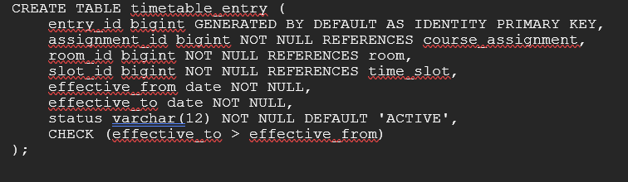

CHAPTER 3

APPLICATION DESIGN USING LOGICAL DATABASE DESIGN
This is a report-only submission. No executable application has been developed. The sections below describe a small Python client that could use the proposed schema; they are an implementation outline, not evidence of a completed interface.

3.1 Application Overview
A future client would serve department coordinators who maintain data and prepare schedules, with faculty members using read-only timetable and workload views. It would read and write the PostgreSQL relations through parameterized transactions. Table 10 records the proposed development environment, Table 11 maps modules to relations, and Table 12 summarizes the planned CRUD operations. The client should display database rejections clearly and should not duplicate business rules that belong in the database.

3.2 Development Environment and Database Connectivity
Table 10. Application Development Environment
Item | Details
Programming Language | Python 3.12 is proposed for a later client; no code is included.
DBMS | PostgreSQL 16 target.
IDE / Framework / GUI Toolkit | Not selected; a small console client would be sufficient for the prototype.
Database Connector / Driver | psycopg 3 is proposed for Python-to-PostgreSQL connectivity.
Operating Environment | Not specified; any supported desktop environment with PostgreSQL connectivity.
Repository Link | Not applicable; this report-only deliverable has no application repository.

3.3 Application Modules and Database Mapping
Table 11. Application Module-to-Database Mapping
Module / Screen | Purpose | Tables Used | Main Operations
Reference data | Maintain departments, programmes, courses, terms, rooms and time slots. | department, programme, course, academic_term, room, time_slot | Create, search, update; restrict removal when referenced.
Faculty and norms | Maintain faculty and effective workload limits. | faculty, workload_norm, faculty_norm | Create/update; view applicable norm by term.
Course allocation | Assign one primary faculty member to each course and section. | course_assignment, course, section, faculty | Create/update; calculate term workload.
Timetable planning | Add or revise recurring room and slot bookings. | timetable_entry, course_assignment, room, time_slot | Search, insert, update; reject clashes and capacity errors.
Substitution | Record an approved one-date faculty change. | substitution, timetable_entry, faculty | Create/search/cancel; validate date and availability.
Reports and audit | Display workload, timetable, free slots, use, clashes and changes. | All operational tables, change_log | Read-only queries, filters and export-ready results.

3.4 CRUD Operations
Table 12. CRUD Operations
Operation | Application Feature / Screen | Table(s) Affected | Evidence
Create | Add a course assignment or timetable entry. | course_assignment, timetable_entry | Design only; no screen implemented.
Read / Search | Find faculty load, section timetable, free room slot or substitution. | Views and related master tables | SQL examples in Appendix A; no live output.
Update | Change an allocation, room, slot, effective period or substitution status. | course_assignment, timetable_entry, substitution | Proposed transaction; no application evidence.
Delete / Controlled Removal | Prefer inactive status; allow deletion only when no dependent records exist. | Master and operational tables | Referential actions and confirmation are specified; no screen implemented.

3.5 Business Rules, Validation and Error Handling
The database is the final authority for workload, date and clash checks. Table 13 summarizes the validation rules and expected messages. A future client should validate required fields before submission, use bound parameters, report constraint messages in plain language, and roll back a multi-row change if any part fails. Deletes of referenced records should be disabled or confirmed; schedule changes should create an audit row in the same transaction.
Table 13. Business Rules, Validation and Error Handling
Rule / Validation | How Implemented | Evidence / Message
Required fields and allowed values | NOT NULL, CHECK and UNIQUE constraints; client validates before insert. | Database rejects invalid values; client should show the constraint message.
Workload limit | Assignment trigger sums active course hours for faculty and term against the effective norm. | "Workload limit exceeded for faculty and term."
No faculty, room or section overlap | Timetable trigger compares date windows, weekday and time intervals; locks resource rows. | "Timetable clash: faculty, room or section is already booked."
Room capacity and valid dates | Trigger checks room capacity and term boundaries; date columns use half-open intervals. | "Room capacity is below section size" or "Schedule dates are outside the term."
Substitution, audit and transaction errors | Trigger validates substitution date and substitute availability; client writes change_log in the same transaction and rolls back on error. | Show a specific rejection; never report success after rollback.

3.6 Reports and Database Operations
Table 14 maps each report to the SQL operation used to produce it.
Table 14. Reports and Database Operations
Report / Operation | SQL / Database Concept Used | Application Output
Faculty workload | Join / aggregate SUM of course.weekly_hours; compare with effective workload_norm. | Allocated, maximum and remaining hours by faculty and term.
Section timetable | View with joins across course, faculty, room and time_slot; filter by date. | Ordered weekly schedule for a section.
Free room slots | Correlated NOT EXISTS and interval-overlap predicates. | Available slots for one room and date.
Room utilization | LEFT JOIN, COUNT and SUM of slot duration. | Scheduled periods and hours per room.
Clash report | Self-join timetable entries; compare faculty, section or room overlaps. | Pairs of conflicting entries; trigger prevents new active clashes.
Substitutions | Join substitution, timetable entry, section and faculty. | Approved changes for a selected date range.

3.7 Application Screens
These are the application screenshots of working dashboard that are included for this report. The proposed screens are described in the module mapping and CRUD tables.
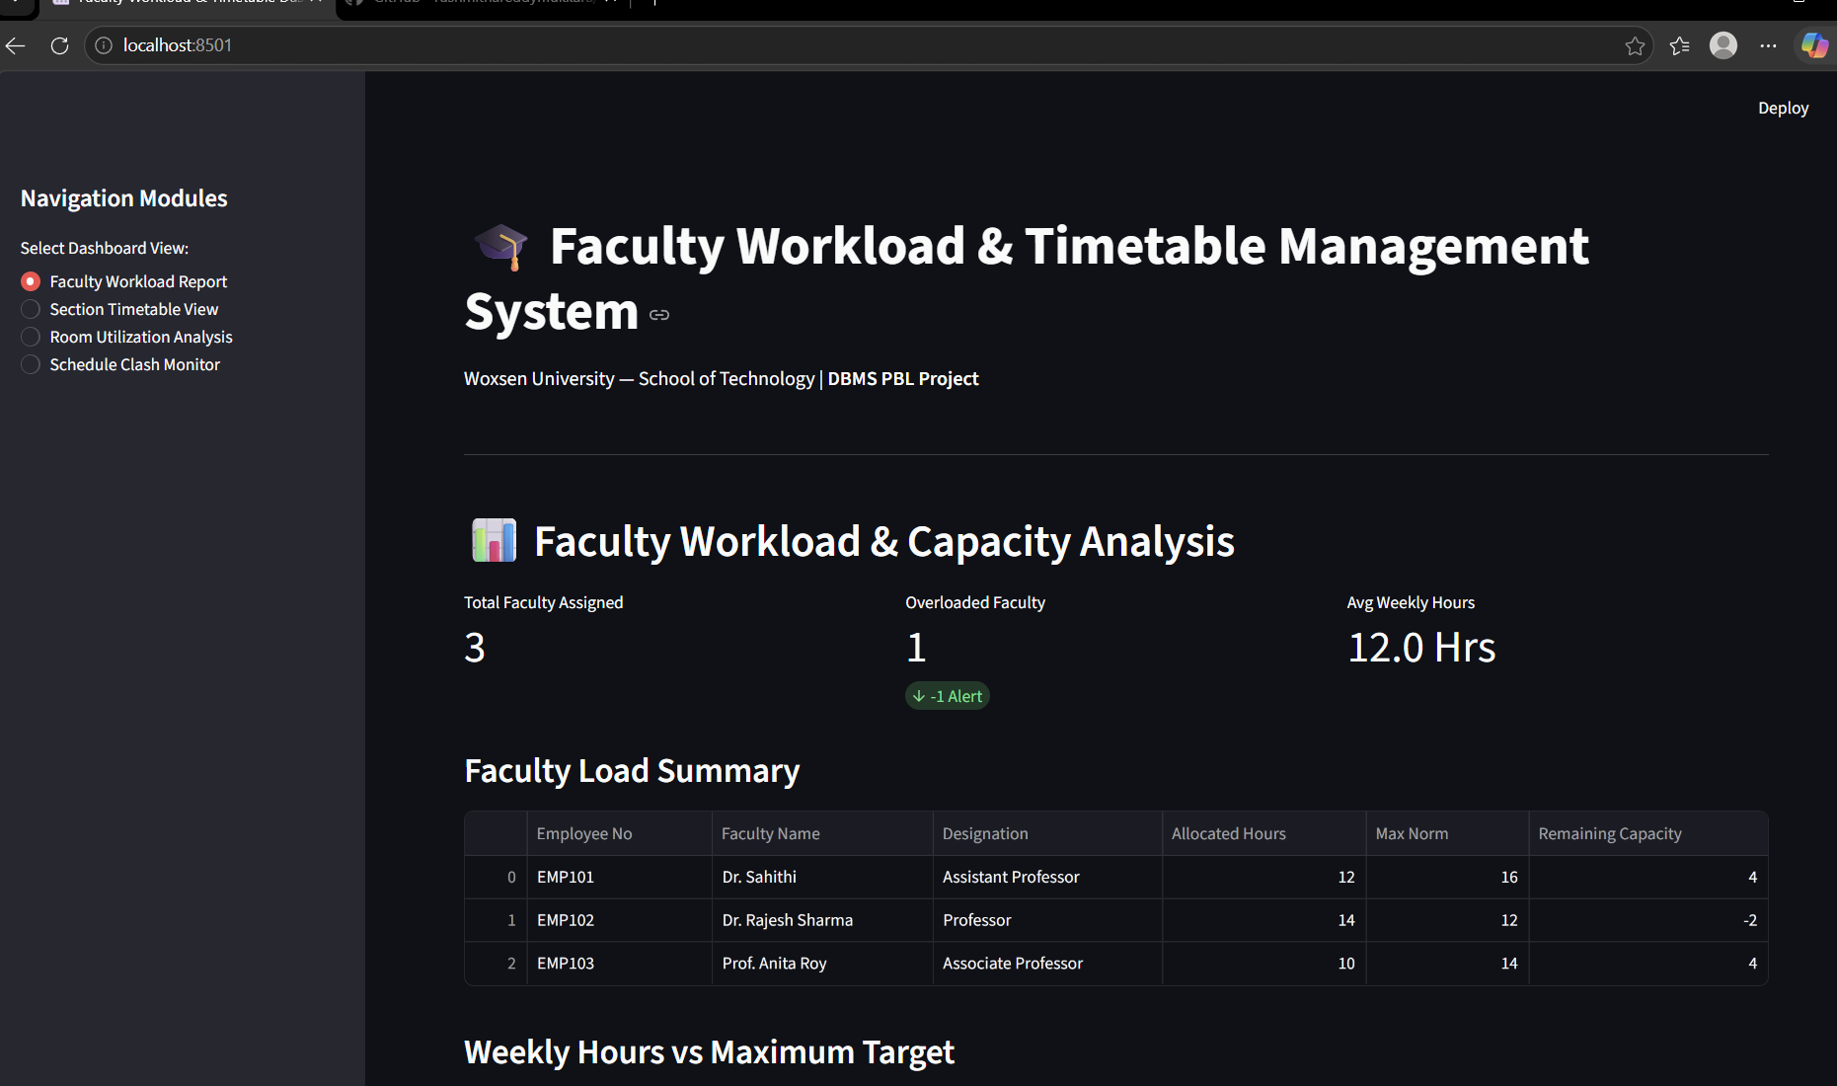

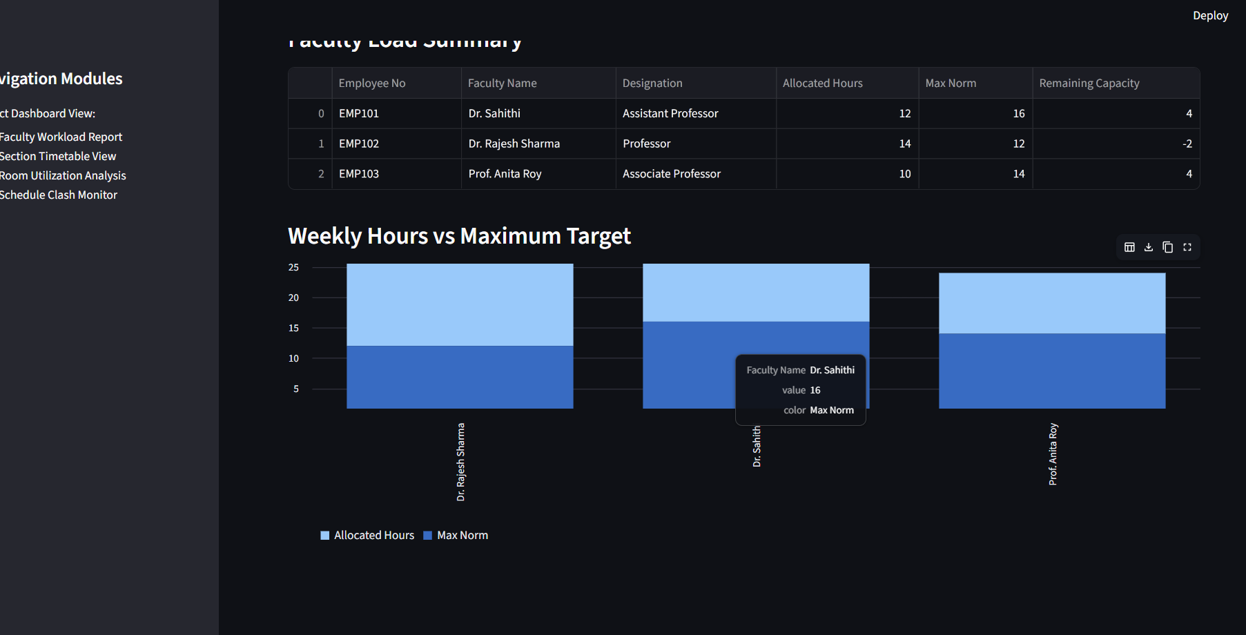

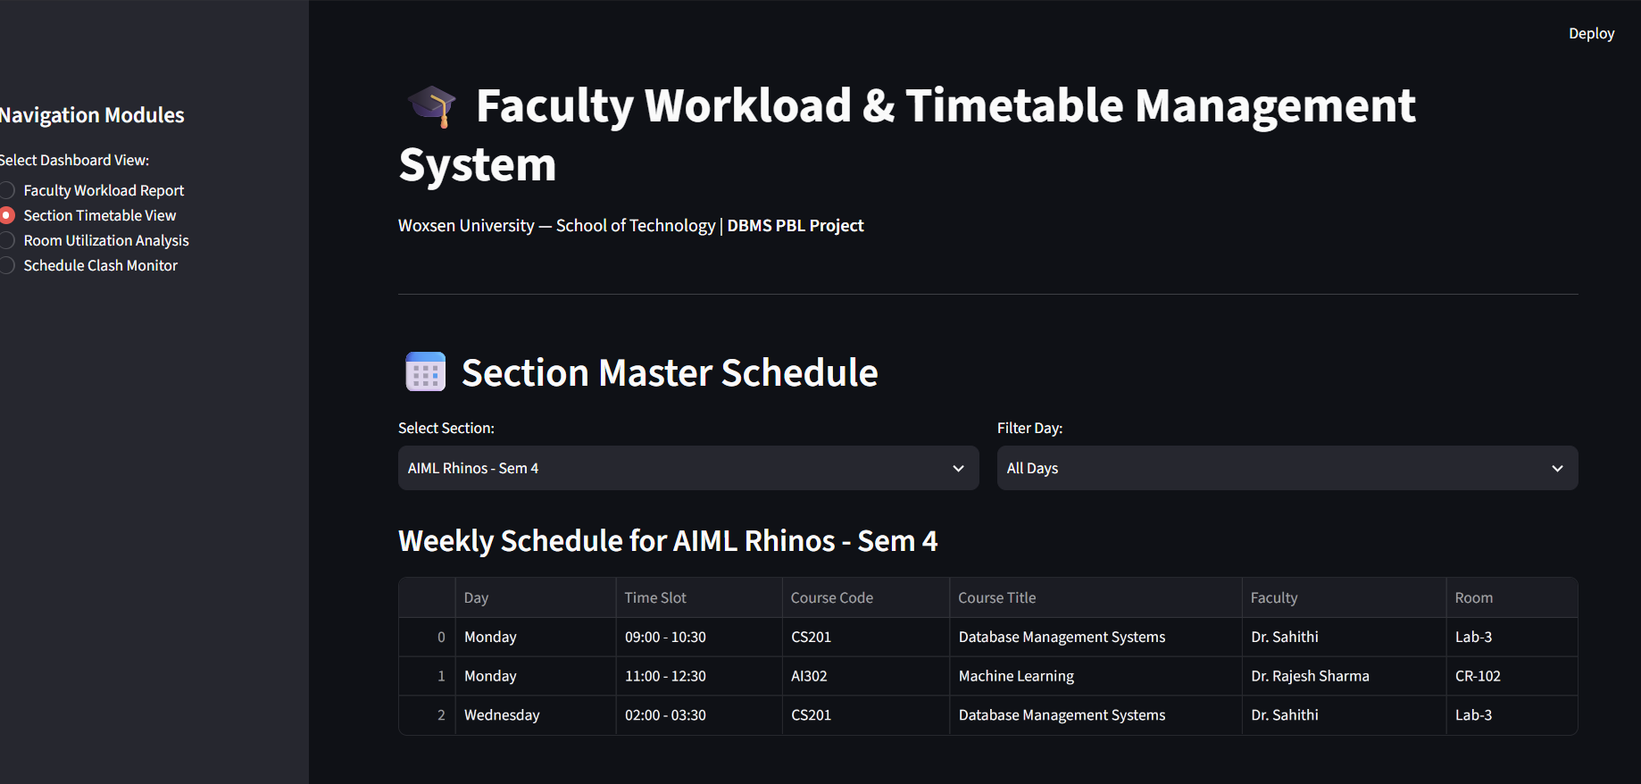
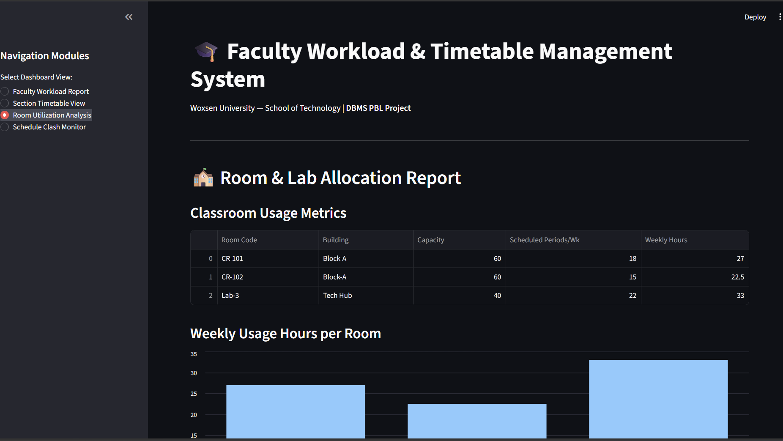

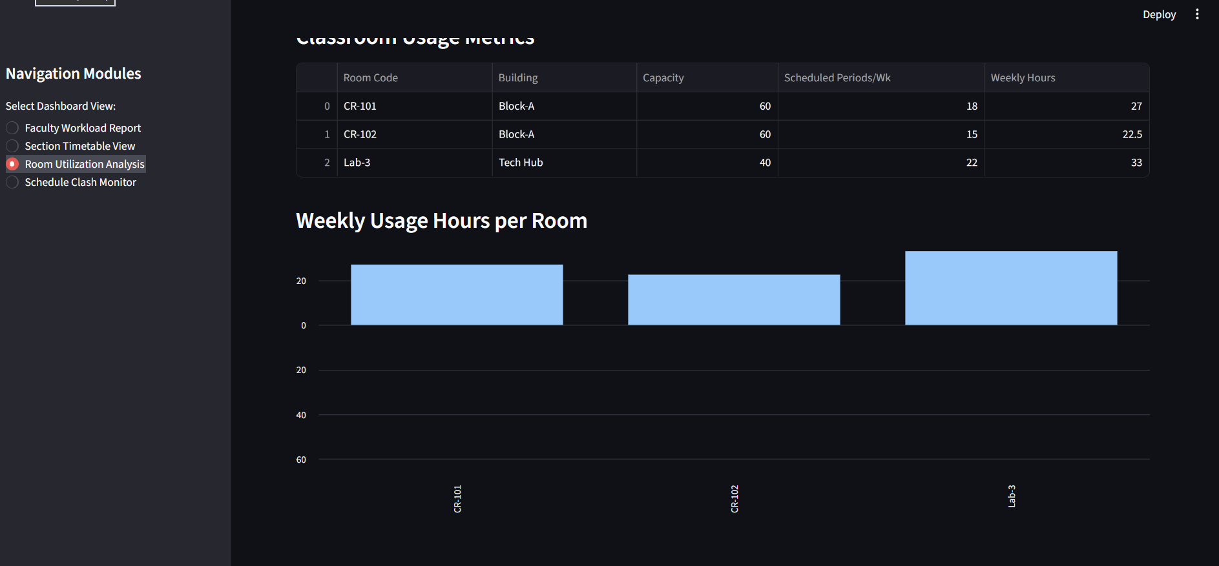
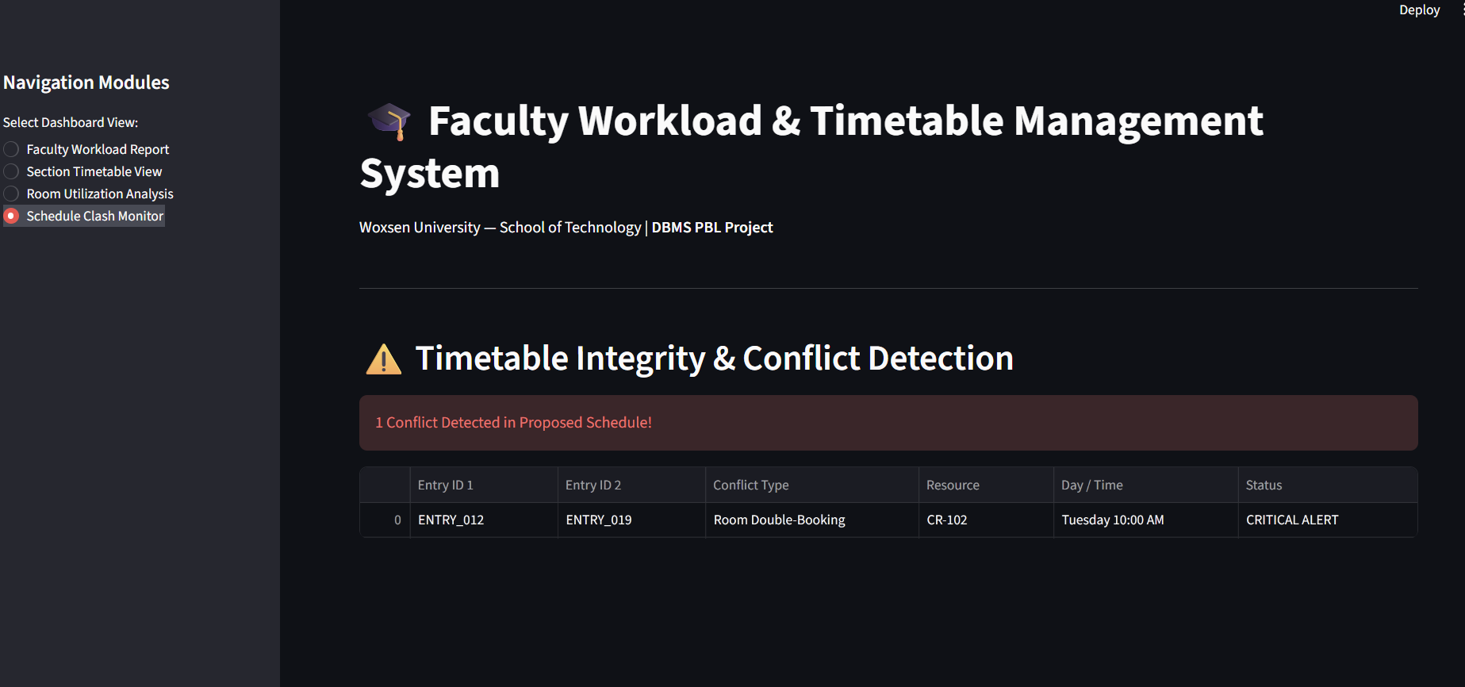

3.8 Testing and Results
Table 15. Test Cases
Test ID | Feature | Input / Action | Expected Result | Actual Result | Status
TC-01 | Valid allocation | Assign a course within the faculty term limit. | Assignment is accepted and workload total is updated. | Not run; no database/app was built. | Planned
TC-02 | Duplicate allocation | Assign the same course to the same section a second time. | UNIQUE constraint rejects the duplicate. | Not run; no database/app was built. | Planned
TC-03 | Workload limit | Add an assignment that raises hours above the applicable norm. | Trigger rejects the assignment and preserves the prior total. | Not run; no database/app was built. | Planned
TC-04 | Faculty / section clash | Schedule a meeting over an active meeting for the same faculty or section. | Trigger rejects the overlapping schedule. | Not run; no database/app was built. | Planned
TC-05 | Room clash / capacity | Reuse an occupied room or assign a room smaller than the cohort. | Trigger rejects the clash or insufficient capacity. | Not run; no database/app was built. | Planned
TC-06 | Effective dates | Use an end date not after start, or schedule outside the term. | CHECK or trigger rejects the invalid period. | Not run; no database/app was built. | Planned
TC-07 | Substitution | Use an out-of-period date, self-substitute or unavailable substitute. | Trigger rejects the invalid substitution. | Not run; no database/app was built. | Planned
Table 15 lists acceptance tests for a later prototype. They are not recorded execution results.
The cases cover valid allocation, duplicate allocation, workload overflow, faculty/room/section overlap, room capacity, effective dates and substitution conflicts. No actual result is claimed because the SQL has not been executed and the application is not implemented. Before demonstration, each case should be run against the database and the actual result should replace the current status.

CHAPTER 4

CONCLUSION
This report defines a relational design for faculty workload and timetable management. It identifies the main users and rules, presents an ER model, maps the entities into fourteen 3NF relations, and specifies representative constraints, trigger logic, sample records and SQL reports. The design keeps master data separate from term-specific allocations and timetable changes.
A future Python client can use the schema for allocation, schedule preparation, substitutions and reporting, but no user interface or database deployment is included here. The next project stage should execute the SQL, run the listed test cases and revise the design in response to observed results.

4.1 Limitations and Future Enhancements
The current report has a deliberately limited scope. Later work could extend the design in these areas:
- Execute and validate the DDL on a PostgreSQL instance; record actual positive and negative test results.
- Build the Python client with authentication, role-based permissions, change history and clear recovery from transaction errors.
- Add multi-campus calendars, holidays, faculty availability preferences, team teaching and automated timetable optimization.

REFERENCES
[1] A. Silberschatz, H. F. Korth, and S. Sudarshan, Database System Concepts, 6th ed. New York, NY, USA: McGraw-Hill, 2010.
[2] PostgreSQL Global Development Group, "Constraints," PostgreSQL 16 Documentation. Accessed: Oct. 4, 2026. [Online]. Available: https://www.postgresql.org/docs/16/ddl-constraints.html
[3] PostgreSQL Global Development Group, "Range Types," PostgreSQL 16 Documentation. Accessed: Oct. 4, 2026. [Online]. Available: https://www.postgresql.org/docs/16/rangetypes.html
[4] PostgreSQL Global Development Group, "Transaction Isolation," PostgreSQL 16 Documentation. Accessed: Oct. 4, 2026. [Online]. Available: https://www.postgresql.org/docs/16/transaction-iso.html

APPENDICES

APPENDIX A - COMPLETE DATABASE SCRIPT
https://github.com/rushmithareddymukkara/DBMS_PBL_Project/blob/main/Appendix_A_PBL.docx

2)
https://github.com/rushmithareddymukkara/DBMS_PBL_Project

APPENDIX A - COMPLETE DATABASE SCRIPT

The complete database script for the Faculty Workload and Timetable Management System is provided in the file Appendix_A_PBL.docx of the repository. It contains the DDL for the eight tables in Third Normal Form (Department, Faculty, Course, Section, Room, Timeslot, TimetableEntry and Substitution), with PRIMARY KEY, FOREIGN KEY, UNIQUE, NOT NULL and CHECK constraints. The composite UNIQUE constraints unique_faculty_slot, unique_room_slot and unique_section_slot on TimetableEntry prevent double-booking at the database level. The script also holds the sample academic data and the analytical SQL queries for faculty workload aggregation, free-room finding and clash detection.

APPENDIX B - APPLICATION SOURCE CODE

The Python source code of the Streamlit dashboard is given in the file python_code.docx, with the complete project code also listed in DBMS PBL REPORT SAMPLE CODE. The application connects to the database, loads the master data and implements the four navigation views: Faculty Workload Report, Section Timetable View, Room Utilization Analysis and Schedule Clash Monitor. It also contains the validation logic that checks room capacity and blocks clashes before a schedule is saved. The full repository is available at https://github.com/rushmithareddymukkara/DBMS_PBL_Project, and its README.md explains the project structure and how to run the application.

APPENDIX C - ADDITIONAL TEST DATA AND OUTPUTS

The Streamlit dashboard output screens are collected in the file STREAMLIT DASHBOARD SCREENSHOTS.docx. They show the faculty load summary with the hours-versus-maximum-norm chart, in which Dr. Rajesh Sharma is flagged as overloaded at 14 hours against a norm of 12. They also show the weekly section schedule for AIML Rhinos - Sem 4, the room and lab usage metrics (CR-101, CR-102 and Lab-3), and the conflict alert for the room double-booking of CR-102 between ENTRY_012 and ENTRY_019 on Tuesday at 10:00 AM. The test cases and their observed results are summarised in Table 15 (TC-01 to TC-08) of the report.

APPENDIX D - REVIEW PRESENTATIONS

The presentations submitted at each evaluation stage are stored in the repository: review_1.pptx (problem statement, literature survey, conceptual ER diagram and high-level schema), Review2_Faculty_Timetable_System.pptx (3NF design, DDL implementation, SQL queries and Streamlit prototype) and Review3_Faculty_Timetable_System.pptx (integrated dashboard results, clash detection, substitution logic and system testing).

